Chapter VI

GEO-CHEMICAL SIGNATURES
Geochemical analysis is an essential tool for the confirmation and study of impact structures and the characterization of the impactites (Koeberl et al., 2012); especially as it can yield information on the presence of meteoritic components in these rocks, if any. The composition of the impactites usually mirror the proportions and composition of the target rock, but, the presence of even small quantities of the impacting meteorite material (projectile) can alter the concentration of certain elements (Espades et al., 2003). However, the chances of survival of the projectile material is usually very rare and even if it survives, the original incorporated material gets diluted (typically <1 wt%) by mixing with volumes of vaporized (and then recondensed), melted and fragmented target rocks (Koeberl et al., 2012). Meteorites have significantly higher concentrations of siderophile elements and PGEs than the average crustal values. ‘Distinctly higher siderophile element contents in impact melts, compared to target-rock abundances, can be indicative of the presence of either a chondritic or an iron projectile’ (Koeberl et al., 2012). We have used the geochemical method of use of elemental ratios, including platinum group elements (PGE: Os, Ir, Ru, Pt, Rh, Pd), which in combination with Ni and Cr represents a very powerful method for the detection and identification of projectiles in terrestrial and lunar impactites. This method is almost independent of the target composition, especially if PGE ratios are considered for most projectile types.(Tagle,2006)
The target rock of Dhala being granitic, it in general has low siderophile element content. An attempt was made to compare different elemental plots obtained by analyzing different impactites samples from Dhala with that of few established impact structures. For this, a set of 13 impactite samples (from surface exposures) were collected and studied for their major and trace element composition, and that of PGEs (Table 1, Table 2). For most of the oxide values, the analyzed samples resemble the composition of that of the average continental crust, excepting CaO, Na₂O, and K₂O, especially K₂O (Fig 6.1). The maximum recorded value of K₂O in the impactites is 11.04 (wt %), from within a melt bearing breccia. This may be due to later K-metasomatism(Reimold et al., 1987). Concentrations of Cr, Co, and Ni also appear enriched with respect to the average composition of the continental crust; the range being 16 -116 ppm for Cr, 11-100 ppm for Ni, and 5- 67 ppm for Co in comparison to granitic averages of 4 ppm, 0.5 ppm and 1 ppm (Taylor, 1964) respectively. This variation indicates some external/other source of enrichment, in all probability admixing of the projectile element with that of the impactites.
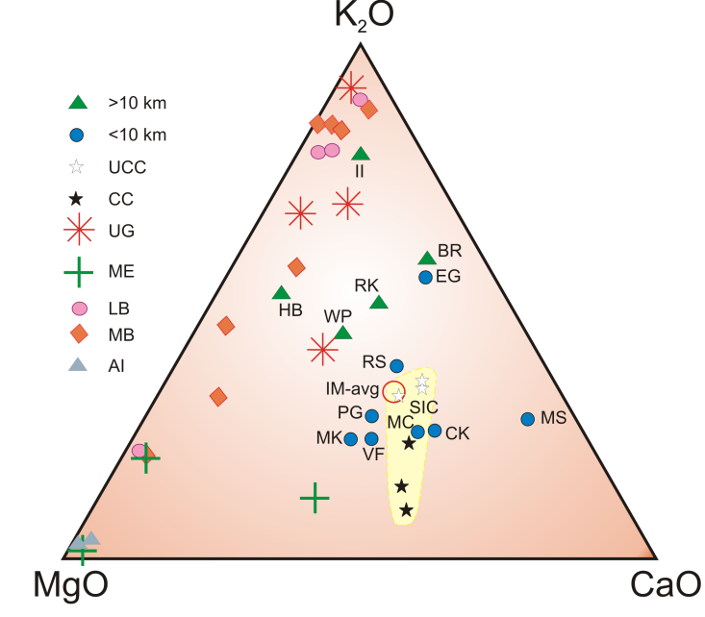 | Fig 6.1 K₂O-MgO-CaO plot showing average compositions of impact melt rocks from craters of different diameters in comparison with the compositions of bulk and upper continental crust (modified after Koeberl et al., 2012). With some exceptions there is a general trend from smaller towards larger craters with their impact melts changing from more upper crust (UCC) towards bulk crust composition (CC). Upper crust: UCC, bulk crust : CC, Il: Ilyinets, BR: Brent, HB: Henbury, RK: Roter Kamm, EG: El’gygytgyn, WP: Wanapitei, RS: Ries, PG: Popigai, MC: Manicouagan, MK: Morokweng, MS: Mistastin, SIC: average of Sudbury Igneous Complex, VF: Vredefort, CX: Chicxulub, IM-avg: average of impact melt rocks, ID: Dhala.
A strong variation in concentration of the different PGEs is observed within the analyzed samples of Dhala. In general, enrichment in Cr, Ni, and Co at ppm level and the variable abundances of the PGEs at ppb level in different meteor groups help in identification of the impactors (Espades et al., 2003, Palme 2008), for terrestrial impact craters. When the PGE concentrations in the impactites are plotted against each other (Fig 6.2, Fig 6.3, Fig 6.4), the trend follows a mixing line between the composition of the average target rock and the impactor (Tagle et al., 2009). These ratios provide a possible criterion for inferring the impactor type, usually if the impactor is a chondrite or an iron meteorite (Espades et al., 2003).
The Cr–Ir diagram (Fig. 6.2) illustrates in general, the mixing pathway followed by impact melt rocks that formed by admixing of the target continental crust and chondrite material (modified after Tagle et al., 2009). ‘Because most terrestrial rocks have Cr/Ir ratios higher than 10⁶, they plot within the ‘‘Earth field”. In contrast, most ‘‘meteorite contaminated impactites” have lower Cr/Ir ratios and therefore plot along the mixing lines towards the composition of the chondritic end member’ (Tagle et al., 2009, Tagle and Hecht, 2006). Data of few established craters are taken for comparison with the data of Dhala impactites. For Dhala, the samples plot beyond the “Earth field” and mostly follow the Cr/Ir enrichment trend within the “grey field” of crustal admixture with chondritic meteorite. It can be inferred from here, that there might be a presence of an extraterrestrial component within the impactites from Dhala, whose composition is near chondritic.

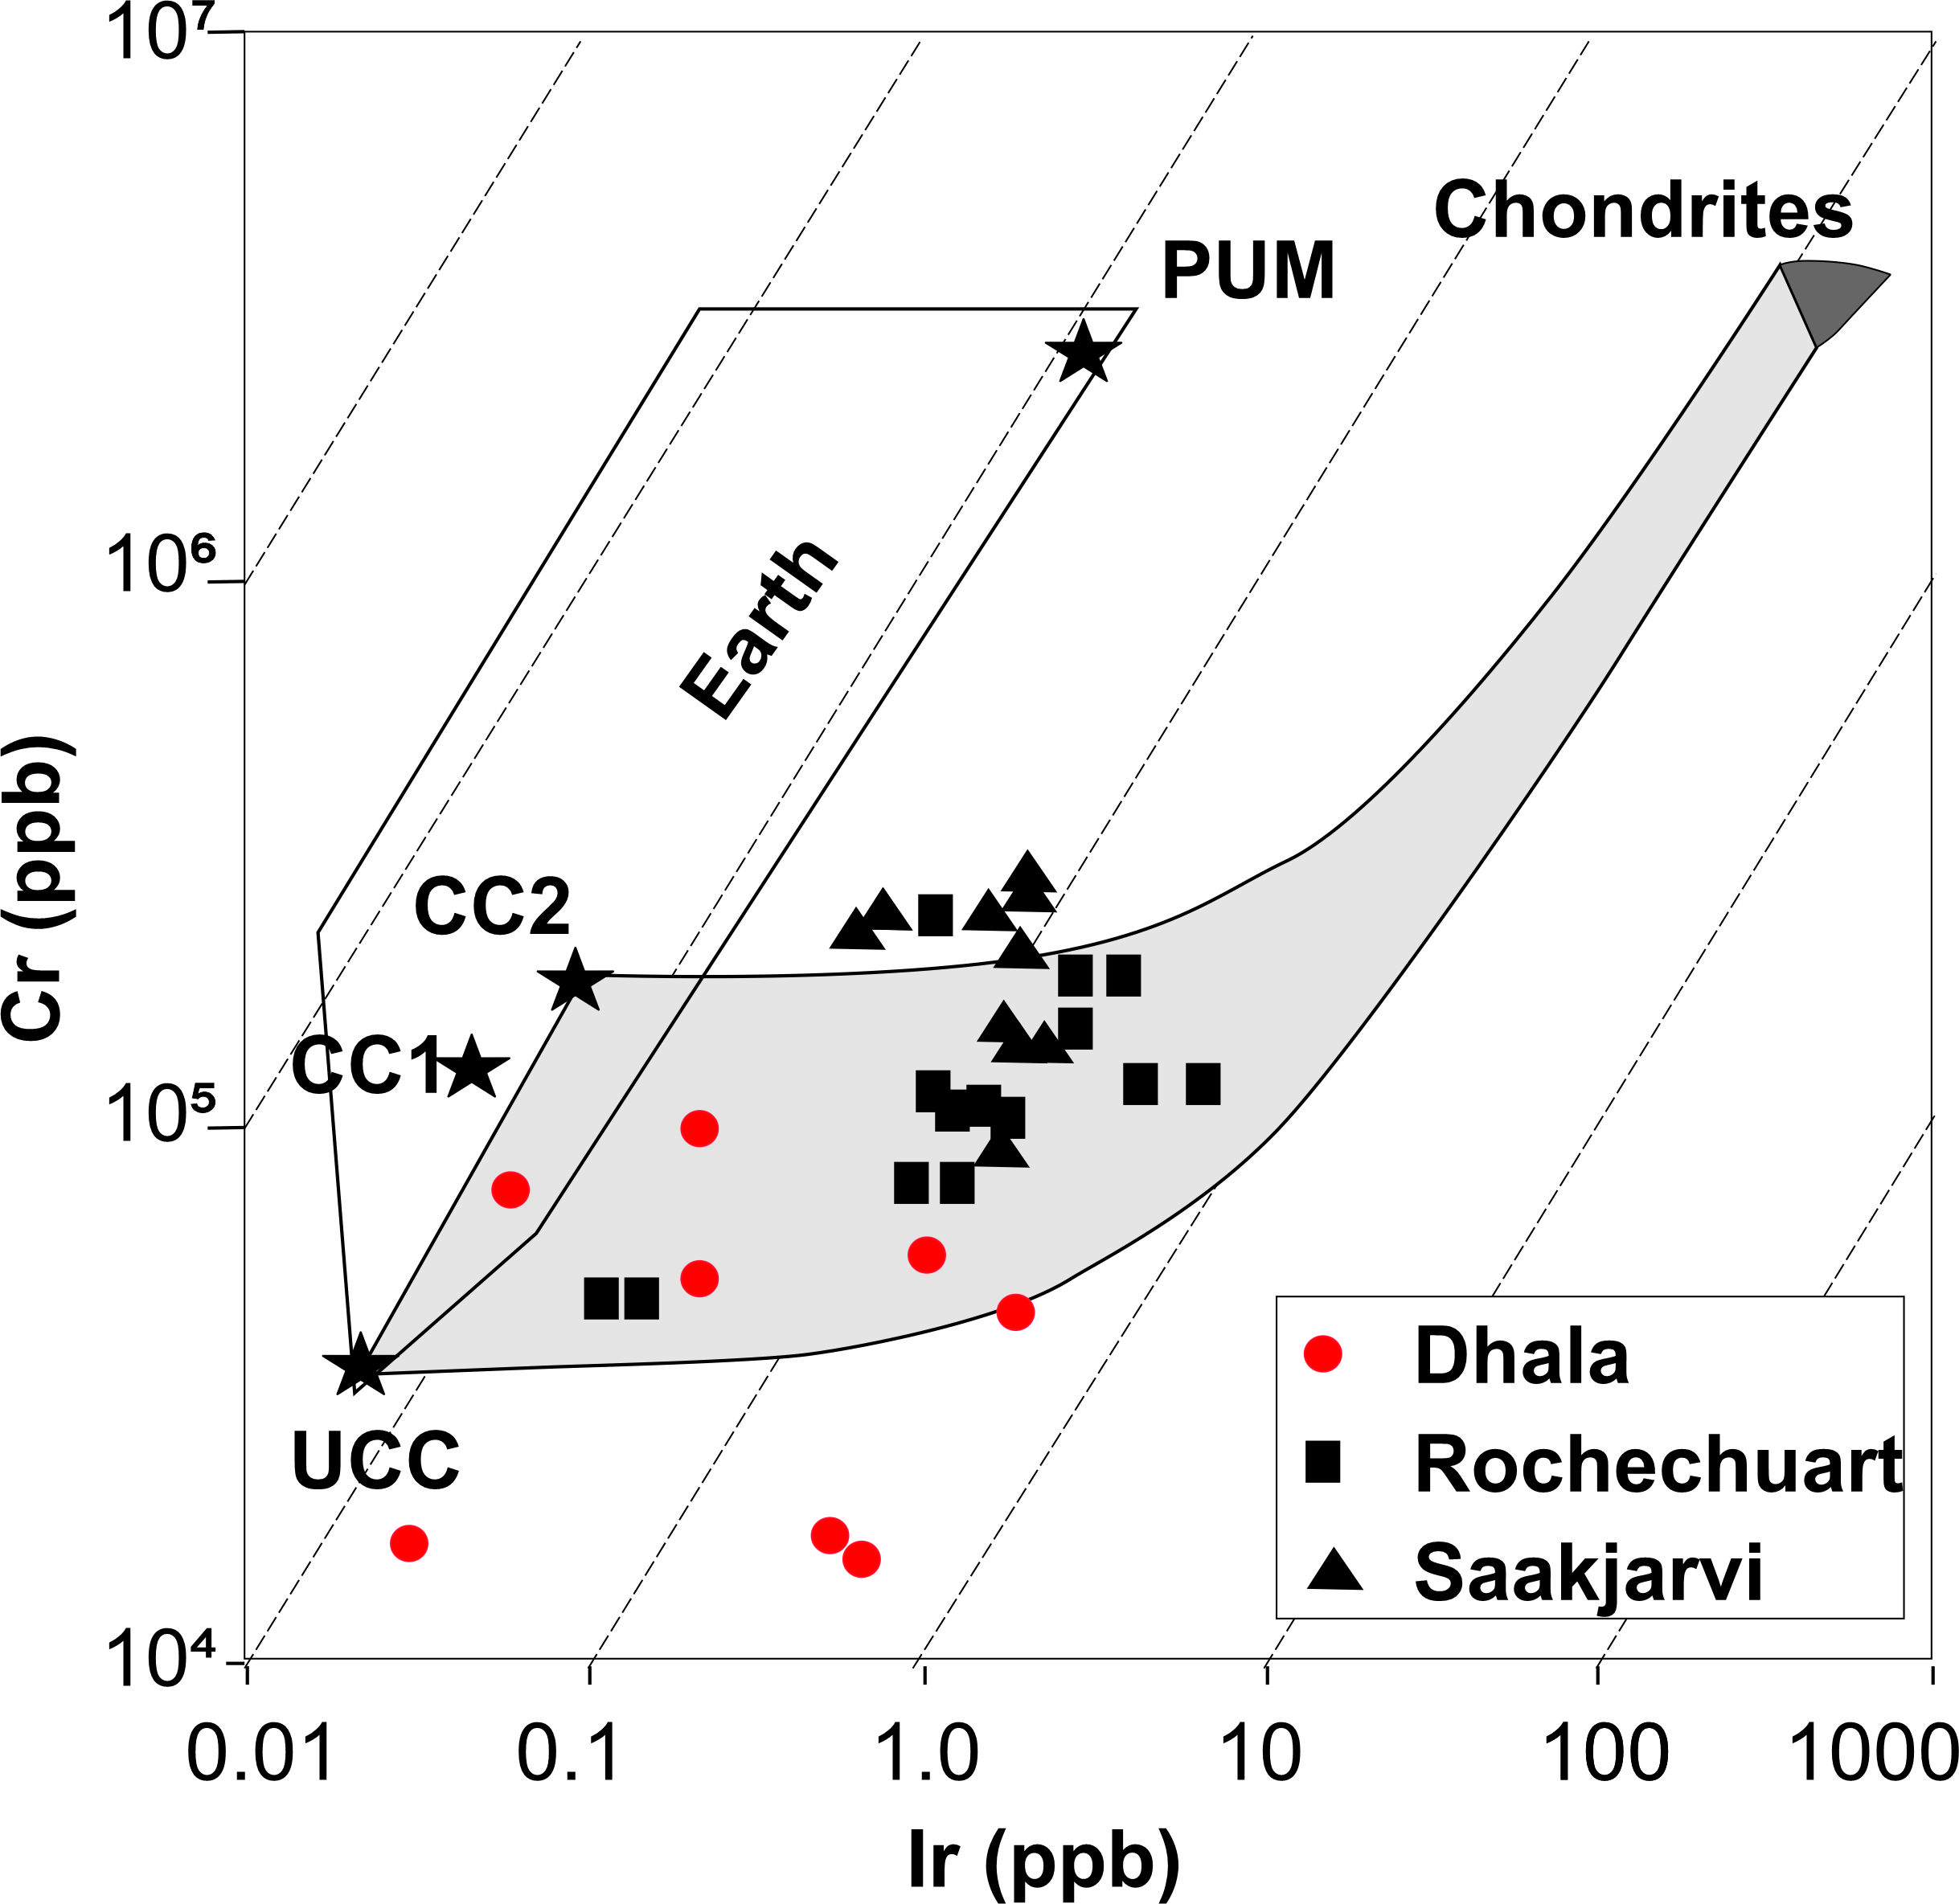 | Fig 6.2 Log-log plot of Cr vs Ir concentrations. The plot of impactites samples from Dhala is overlain and compared with that of terrestrial lithologies, Chondrites and established impact craters (modified after Tagle et al., 2009)  The grey field indicated the most-likely mixing zone between chondritic projectiles and terrestrial target rocks.  UCC: Upper continental crust; CC: Continental crust, CC1,Wedepohl (1995); CC2, Taylor and McLennan (1985); PUM,  primitive upper mantle.  The data from Dhala impactites plot mostly within the grey-field indicating an admixture between the target rocks with that of a near chondritic material.

For further characterization of the projectile component, inter-elemental plots of the siderophiles and the PGEs are considered (Fig 6.3, Fig 6.4). The slope of the mixing line, determined by regression analysis, represents the PGE ratio (e.g. Ru/Ir, Pt/Ir, etc.) of the impactor, without the need to make a correction for indigenous PGEs (Koeberl, 2012).
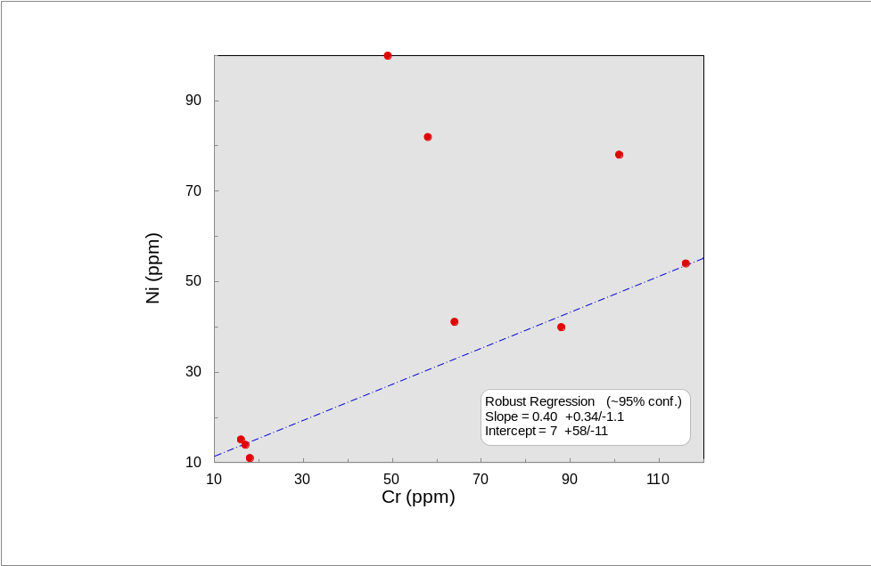 | 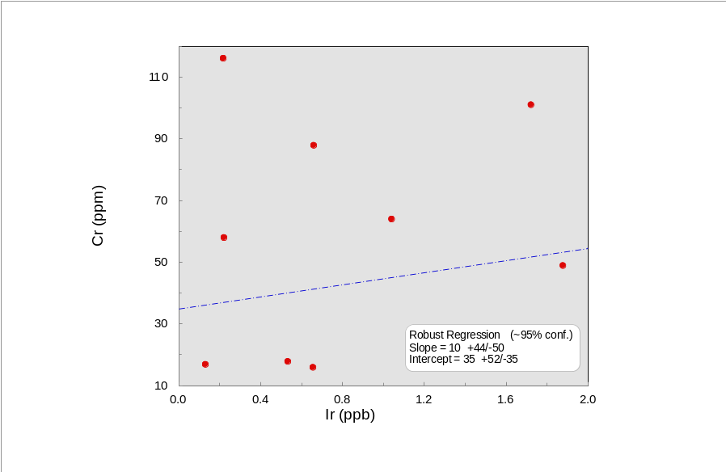
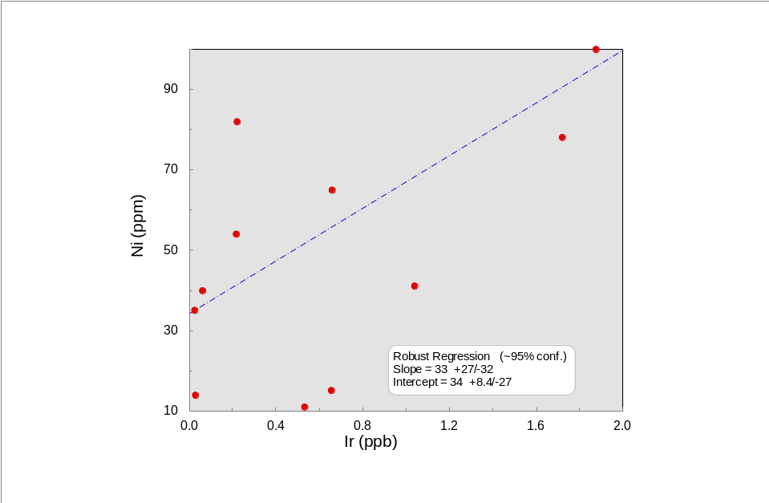 | 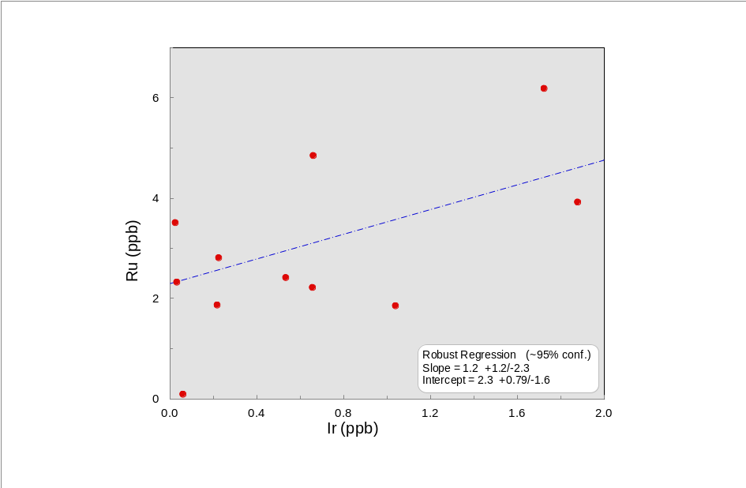
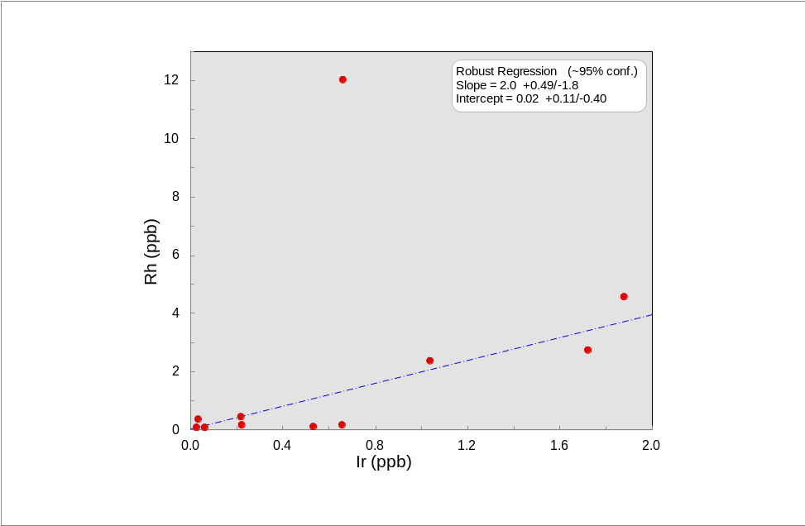 | 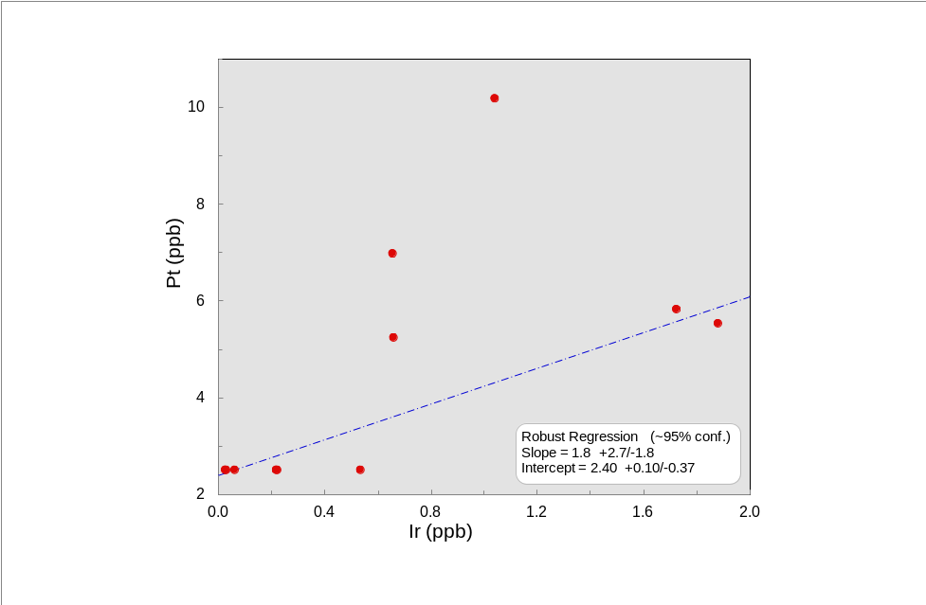
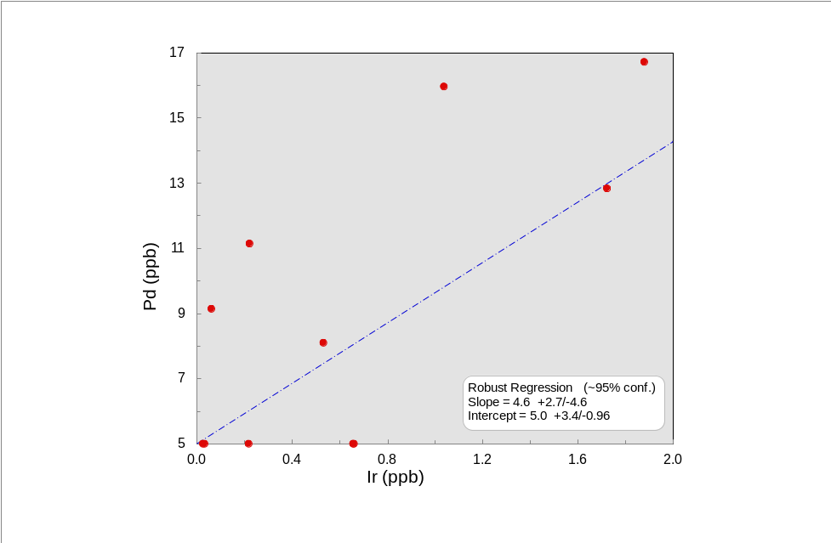 | Fig.6.3 Correlations of the concentrations of Ni, Cr, and PGEs in the impactites of dhala Impact crater. The correlation parameters given on the diagrams were calculated with ISOPLOT.(Modified after Tagle et al., 2009).  Note that the elements in the Cr/Ir and Ni/Ir diagrams have different units  (Ni and Cr in ppm and Ir in ppb): the values for the slope for the Ni/Ir and Cr/Ir ranges should be multiplied by 1000 to obtain the ratios).
For a better characterization of the projectile the inter-elemental ratio, calculated from linear regression of the concentration of the two elements has been considered (Fig 6.3). The slope of the mixing lines is matched with the range in Chondrites (referred from Tagle et al., 2009) to interpret a probable projectile composition/ component for Dhala Impact structure. (Table 1).
Table 1: Comparative data of the probable projectile element ratios from impactites of Dhala Impact crater, with that of the range in chondrites. The linear correlation values were calculated using Isoplot.
Element Ratio | Impactites from Dhala | Range in Chondrites
Ni/ Cr* | 0.40 + 0.34/-1.1 | 2.6 - 9.7
Cr/ Ir* | 10 + 2.7/-3.2 | 3.2- 10.5
Ni/ Ir* | 33 + 2.7/-.32 | 16.2 -31.4
Ru/ Ir | 1.2 + 1.2/-2.3 | 1.42 -1.62
Rh/ Ir | 2.0 + 0.49/-1.8 | 0.24 - 0.36
Pt/ Ir | 1.8 + 2.7/-1.8 | 1.50 - 2.10
Pd/ Ir | 4.6 ± 2.7/-4.6 | 0.9 - 1.62
*Values for Ni and Cr are in ppm and Ir is in ppb, range*1000=ratio. The values of the inter-elemental range in Chondrites are referred from Tagle et al., 2009.

The interelemental plot of Pt/ Ir was compared with that of data of Morokweng, South Africa (After Tagle et al., 2009) (Fig 6.4). The observed trend for Dhala, is seen to follow the mixing line between the representative composition of the target rocks and the impactor of Morokweng (the impactor composition was found to be similar to that of a chondrite). As discussed above, the slope of the mixing line, determined by regression analysis, represents the PGE ratio of the impactor, without the need to make a correction for indigenous PGEs (Koeberl, 2012).
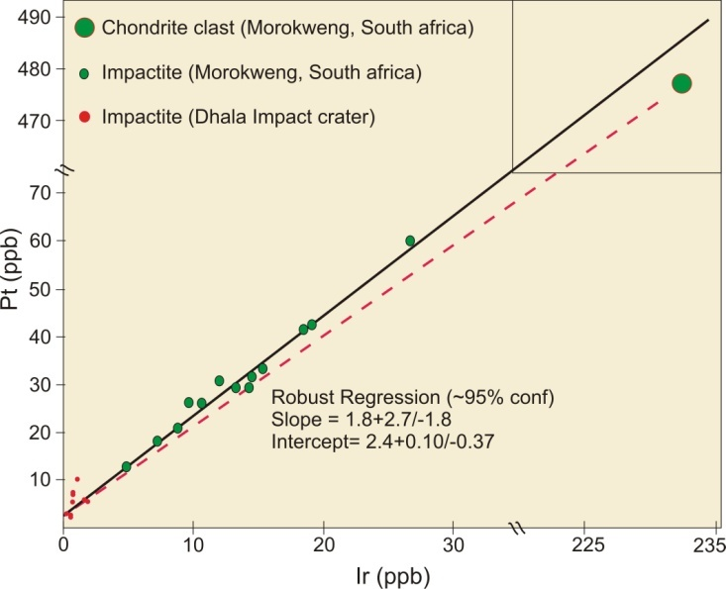 | Fig 6.4. Regression between Pt and Ir contents for impactites from Dhala impact crater (shown in red); the data is compared with that of Morokweng, South Africa, (modified after Tagle et al., 2009). A clast of LL ordinary chondrite discovered in the Morokweng M3 borehole plots close to the regression line projected through the impact melt rocks.

To detect the traces of the impactor, study of selected samples were carried out through whole rock analysis in Central Chemical Lab, and Isotopic components at IISc, Bangalore. Sr-isotope analysis of 11 data for melt bearing breccia samples from Dhala crater was carried out at CEaS, IISc Bangalore. The radiogenic isotopic compositions are consistent with those observed in granitic rocks. The high values in some samples (⁸⁷Sr/ ⁸⁶Sr: 1.5) could be linked to K-metasomatism that has been suggested in the Dhala rocks in previous paragraphs also from the oxide plot (Fig 6.1). No extra-terrestrial role/ or absence of it could be confirmed with the available set of data, isotopically.
However the analytical data (geochemical) from the representative samples of impactites collected from Dhala, were used to plot inter-elental ratios of few siderophiles and PGEs. Considering the plots of Fig 6.2, Fig 6.3 and Fig 6.4, a probable near chondritic composition of the impactor is interpreted for the Dhala impact structure.

